**Multiplying Whole Numbers by Non-Unit Fraction Notes**

Let’s look at an example: What is $\frac{3}{8}$ of 24?

Well….I can think of 24 being split evenly into eight groups (my denominator) to find out how much would be in one group 🡪 of 24 or 24 ÷ 8

**+ +**

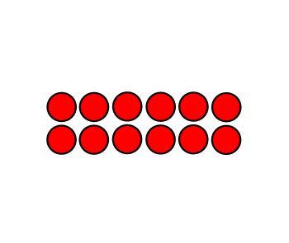

If $\frac{1}{8}$ of 24 = ______3_______ because ___________24 ÷ 8 = 3____________

Then….. $\frac{3}{8}$ of 24 = _____9____ because _______24 ÷ 8 x 3 = 9________

** My answer is logical because I know I am taking a piece (or a fraction) of my total…so my answer has to be less than what I am starting with!**

So in actuality I am taking my whole group and dividing it by my denominator and then multiplying it by my numerator – how many of those groups I need ☺

*Total* ***÷ by the denominator x the numerator = answer***

Let’s try a few!

$\frac{2}{5}$ of 25 = ___**10 $\frac{6}{7}$**______ of 35 = _________

***25 ÷ 5 x 2 = 10***

$\frac{4}{6}$ of 42 = $\frac{5}{8}$_________ of 24 = _________

**Multiplying Whole Numbers by Non Friendly Fractions Notes**

Sometimes the factional part of the whole that you are looking for doesn’t always fit in equally. What do you do in this case? You follow the same steps but you will have to think about it a little differently.

**Let’s look at an example:**

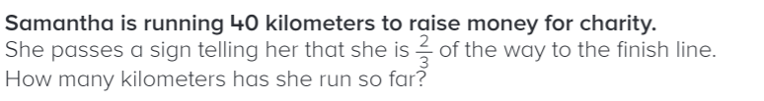

I need to find out what 2/3 of 40 miles is….so my first step is to figure out how much 1/3 of 40 miles would be and multiply it by 2 to find out 2/3.

*We have already done this before last week! Think about 40 groups of 1/3 – how many thirds will you have?*

Step 1: Find out the unit fraction of the whole:

$$\frac{1}{3} x 40= \frac{40}{3}$$

Step 2: Multiply your answer by how many parts you need:

In this problem, I need to find two thirds so I am going to multiply my answer by two.

2 x $\frac{40}{3}$ = $\frac{80}{3}$ = 2 $6\frac{2}{3}$

***Samantha has traveled 2 $6\frac{2}{3}$ kilometers***

Multiply the numerator by the whole number and keep the denominator the same! Then Simplify☺

You could also try it in one-step!

$\frac{2}{3} x 40= \frac{80}{3}$ = 2 $6\frac{2}{3}$